Week of September 30
ELA News  We will begin our second Unit in ELA. Our essential question of the week is ‘Why do we have rules in school?’ We will discuss the various answers to this question and understand why rules are important. We will also be reading How Do Dinosaurs Go To School and Friends At School. We will use our imaginations and create stories telling what would happen if a dinosaur came to SKD. Our sight word is ‘like’ and we will be talking about the letters P, Q, R, S, and T. | Math News  We will continue with Chapter two and learning about shapes. We will explore how shapes are alike and different and go on a shape hunt in our classroom.
Science News  We will begin to learn about pumpkins. We learn about the different parts of a pumpkin and the life cycle. 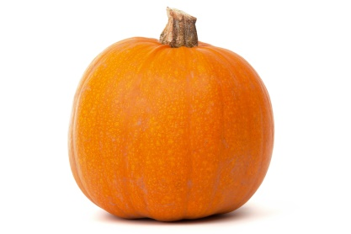 | Religion News  We will be continuing to learn about the different gifts that God has given us. We will discuss why the gift of water is so important and how it helps us.
Upcoming Events this Week  September  30: Food drive items due  October  1: Closing of 40 Hours Mass at St. Bede  2: No School Teacher In-Service | Reminders  *Please complete all homework in pencil  *Please have the girls wear shorts under their jumper

