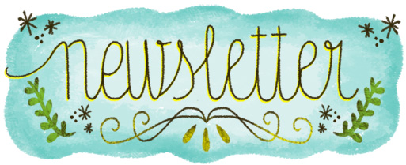
Week of September 23
ELA News  This week in Language Arts we will be beginning our first Unit. Our two stories this week are What Makes a Family and Building With Dad. Our sight word this week is I and we will be discussing the letter sounds of Kk, Ll, Mm, Nn, and Oo. During center time we will focus on writing our names and we will be doing a Scarecrow writing to prepare for fall. | Math News  This week we will finish up our first chapter on sorting and we will begin our new chapter on shapes. Everyone has been doing a wonderful job sorting various classroom objects and describing their attributes.
Science News  This will we will continue to learn about apples. The children had a great time last week with apple tasting, learning about the parts of an apple, and the life cycle of an apple. They will be bringing home their apple journals at the end of the week. | Religion News  This week will be learning about God’s gift of the Sun. We will build an understanding that light is an essential element that we need to survive. We will also celebrate the feast day of St. Vincent DePaul by bringing in cans for our food drive.
Upcoming Events this Week  September  24: Conservation Caper Assembly  26: Good Time Ticket Jean Day  Yankee Candle Kickoff Assembly  27: Spirit Day Jean Day  *8th grade bake sale all week during lunch* | Northampton Day is Saturday September 28, come out and have some fun!

