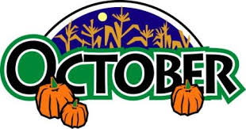
Week of October 21
ELA News  This week we will focus on the letter S and sight words the, like, and, & I. Our stories for the week are The Little Red Hen, The Handiest Things in the World, I Can Do It, At the Playground, and Fun with Friends. We will also have out first unit assessment. | Math News  We will wrap up our chapter on patterns and begin to talk about positional words. We will be focusing on left, right, under, over, top, middle, bottom, inside and outside.
Science News  In science we will begin to learn about Nocturnal Animals. We will discuss the adaptations these animals have and how they use them to survive at night time.  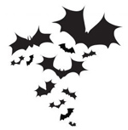 | Religion News  We will continue to learn about the wonderful gifts from God. As a class we will brainstorm ideas on how we can take care of these gifts and show respect for them. This week we will focus on the gift of Animals. We will also be attending 9:00 Mass this Friday. Please review appropriate behavior at Mass.
Upcoming Events this Week  October  21: Scholastic Book Fair  23: High School Night 6:30-8:00  25: Grandparents Day | *If you did not send in Book Fair money on Monday you may send it in another day and we will visit the fair during rest time.  *Grandparent’s Day is Friday. Please send in all RSVP’s ASAP.

