NEWSLETTER

Week of October 14
ELA News  We will explore different jobs that people do any explore why each job is important. Our stories for the week are Pizza at Sally’s and Everybody Works. We will also be focusing on the letter Mm and he sight word ‘and’. | Math News  We will be wrapping up our shape chapter. Students will be learning about how to combine and separate figures. We will also explore color, shape, size, and growing patterns.
Science News  This week we will be focusing on Fire Safety. We will go over fire safety rules and have a fire drill. We will also have a fire truck come for a visit.  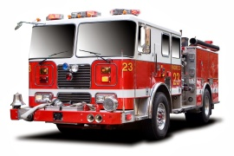 | Religion News  This week we will learn about God’s gift of the land. We will be going to Mass for the first time on 10/25 for Grandparent’s Day. Please review the expected behavior for Mass with your child.
Upcoming Events this Week  October  14: No School, Columbus Day  16: Fire Truck Visit  17: Good Time Ticket Jean Day  18: SKD Spirit Jean Day | Reminders  *Please complete all homework in pencil.  *Please have the girls wear shorts under their jumper.  * Grandparent’s Day is October 25, more information to come.

