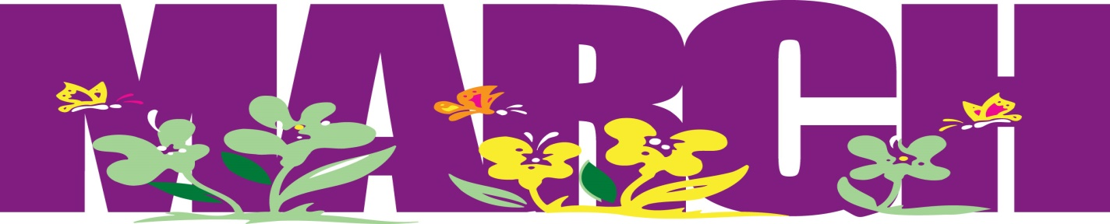
Week of March 9th
ELA News  This week we will read the books “Simon and Molly plus Hester” and “Zin! Zin! Zin! A Violin”” Our sound for the week is the short sound of /o/, and the sight words are:  make, them, give, play, say, new  *Please make flashcards for the sight words to practice at home.* | Math News  We will finish up chapter 7 and take a test on addition. We will begin chapter 8 on subtraction.
Science News  This week we will continue our learning journey about weather. For the next few weeks we will read books, watch videos, perform experiments, and observe/record weather!  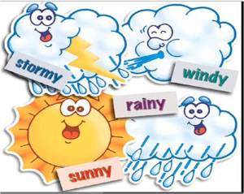 | Religion News  We will learn that the Church is the family of God, and we will read/discuss Sunday’s Gospel.
Important dates this week

