NEWSLETTER

Week of October 7
ELA News  We will discuss why people have to take care of their pets after we read Please, Puppy, Please and I Have a Pet. In grammar we will focus on Nouns and understanding that they are names for animals and things. Our sight word for the week is ‘the’. | Math News  We will wrap up 2D and 3D shapes and begin to learn about patterns. We will create our own color, shape, size, and growing patterns following given rules.
Science News  We will continue to learn about and explore pumpkins. We will complete our Pumpkin Journals and observation sheets.  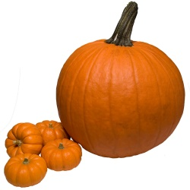 | Religion News  We will be learning about God’s gift of the land, how it helps us, and how we can take care of it.
Upcoming Events this Week  October  10: Picture Day. Order forms will be coming home this week. All students will have their picture taken, even if you choose not to order any pictures. Students may wear their uniform or dress clothes.  11: $1 Jean Day. Money will be donated to Unite for HER. For more information visit uniteforher.org | Reminders  *Please complete all homework in pencil.  *Please have the girls wear shorts under their jumper.  * Grandparent’s Day is October 25, more information to come.

