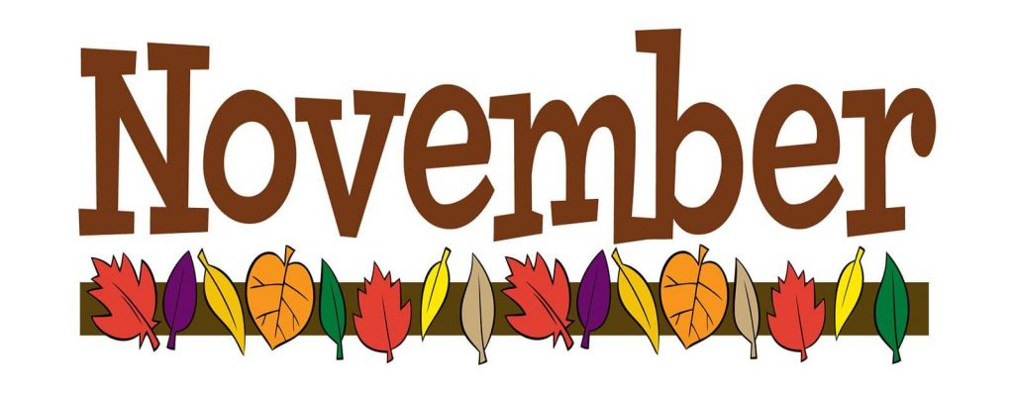
Week of November 4
We have been very fortunate to have Mrs. Barret with us since October 28. The students are loving getting to know her! I am extremely grateful for the wonderful gift basket for the baby. It was very thoughtful and appreciated. Thank you for all of your love and support during this exciting time for me and my family.
ELA News  This week we will be focusing on the letter T and the sight word ‘we’. We will also be discussing how people and animals communicate. We will be reading Amelia’s Show and Tell Fiesta and Mice Squeak, We Speak. | Math News  We will finish up our chapter on positional words and take our Chapter 3 test. Next week we will begin learning about numbers and their quantities.
Science News  We will continue to learn about Trees and Leaves. We will be observing the environmental changes outside our window. | Religion News  We will begin learning about the season of Ordinary Time. As a class we will discuss how we can incorporate prayer into our everyday lives.
Upcoming Events this Week  November  3: Open House 12-2  7: 11:45 Dismissal, Parent Teacher Conferences  8: No School, Parent Teacher Conferences | *Please take some time to fill out the thankful leaves coming home on Monday. We will use these on our November bulletin board. Please send them back ASAP.  * Blue folders will be coming home Monday with important conference papers.

